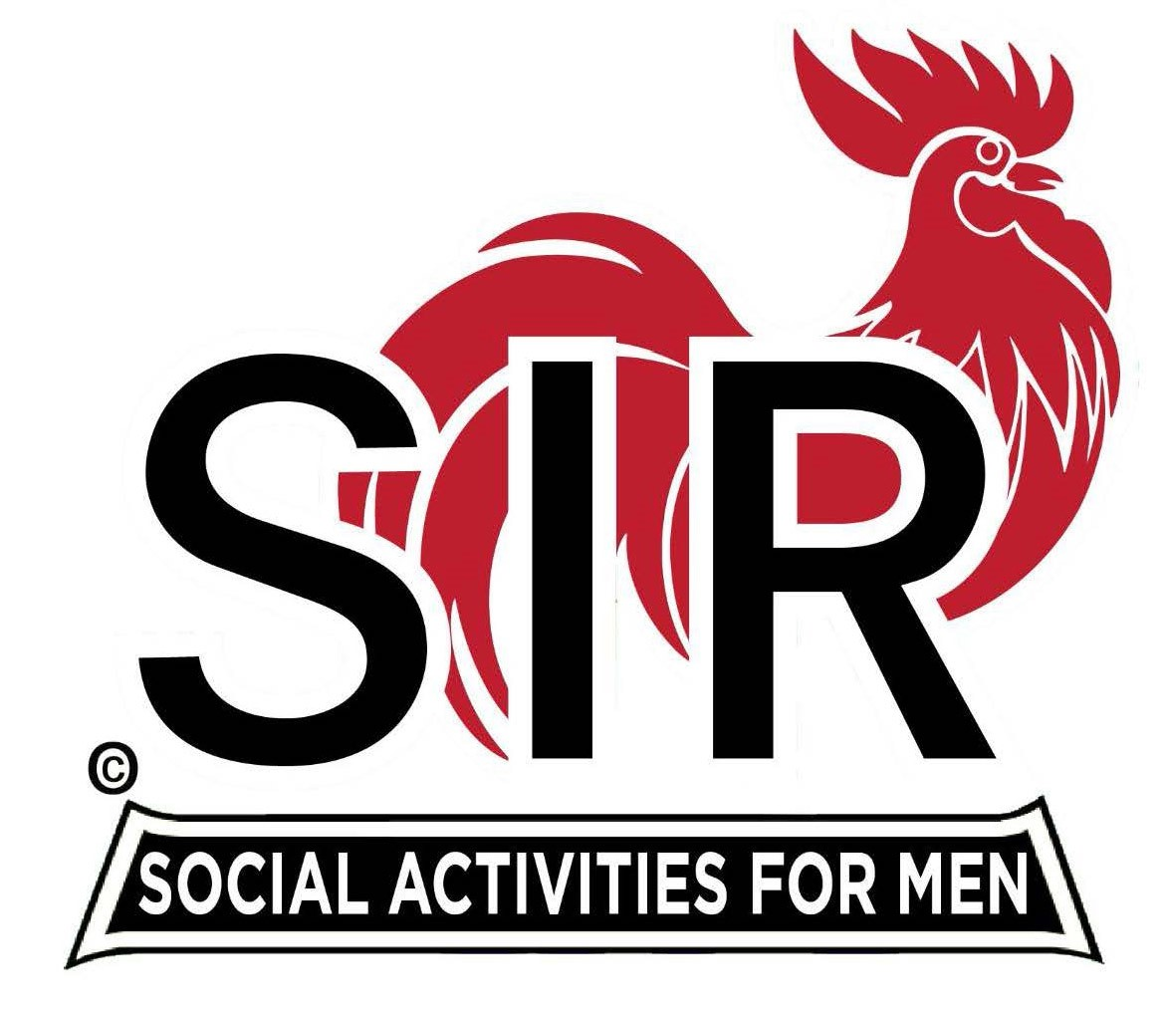
Las Trampas Branch 116
BEC Meeting Agenda
October 16, 2023, 9:15 AM at Boundary Oak
The Mission of SIR is to enhance the lives of our members through fun activities, events and luncheons while making friends for life.

9:15 am Call to order; Secretary, Paul Ramacciotti – Confirm quorum and
Approval of September 18, 2023 BEC meeting minutes

9:20 am Standing Reports

- Treasurer – Jeff Johnson, Charlie Guthrie

- Treasurer’s Report
- 2024 Budget Update

- Luncheon Report – Mike Schneider

- October 16, Boundary Estimated Count

- Membership – Don Schroeder

4. RAMP Department Head Reports:

- Recruitment – Don Schroeder
- Activity Coordinator – Mike Ward
- Member Relations - Michael Barrington
- Publicity – Paul Russell

9:40 am Little SIR Updates – Alan Pope

- Speaker Info – John J. Geoghegan
- Birthday Boys – October

9:50 am Updates & New Business

- Farmer’s Market Update – Roger Craig
- Holiday Party Participation – Roger Craig
- Past Big Sirs – Roger Craig
- BO Contract – Alan Pope

10:15 am Adjourn: Lunch Preparations

